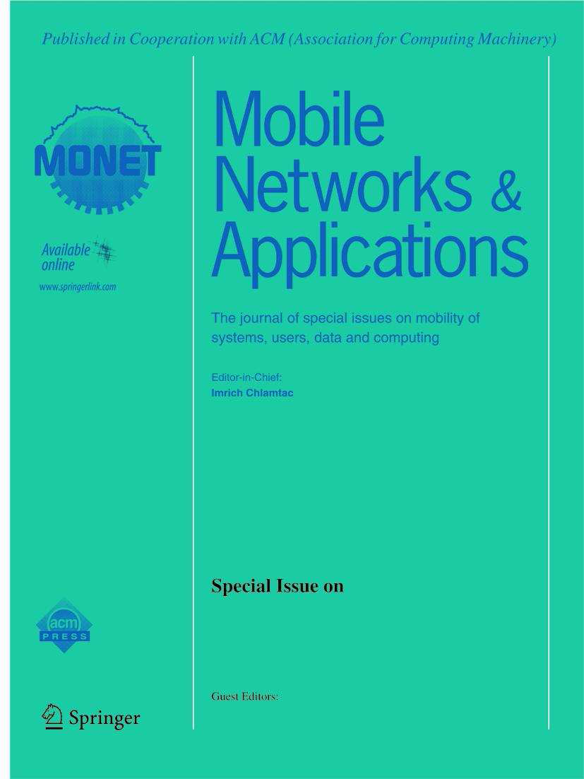
Call for Papers
ACM/Springer Mobile Networks & Applications (MONET)
SPECIAL ISSUE ON
Industrial Wireless Networks: Emerging Trends, Challenges and Applications

http://www.springer.com/engineering/signals/journal/11036

Overview:
The evolution of the communication networks (e.g., technology of industrial wireless communication), mobile computing, as well as the cloud computing/big data technique, is producing the industrial revolution. Industrial Cyber-Physical Systems (ICPS) that integrate the physical systems with sensing, computing, and actuation exhibit new capabilities with unprecedented dependability, safety, security, and efficiency. In ICPS, wireless sensor technologies are playing an increasingly prevalent and important role in bridging the gap between the physical components and cyber spaces.

Now, wireless sensor technologies in ICPS are still facing many issues and challenges, such as reliability, energy consumption and data aggregation, real-time performance, and severe environmental conditions. Furthermore, in different industrial domains, we need to adopt the personalized sensor technologies. For example, with the support of sensor technologies, auto makers hope to utilize the internet of vehicles to collect the wear information of all engines. And this information may help them to improve the performance of auto engine in next design. Besides this, the other domains, such as smart grid, intelligent manufacturing and internet of vehicles, also depend on wireless sensor technologies to improve the intelligent level.

Topics
Topics of interest include, but are not limited to, the following scope:
- Sensor network architecture in ICPS  - Wireless protocol in industrial domains  - Wireless industrial standards (e.g., Wireless HART, ISA SPl00, and WIA)  - Emerging protocols and standards  - Wireless networks for industrial automation  - Event-based control in wireless sensor networks  - Evaluation and comparison of the real-time performance  - Advanced control technologies in industrial wireless networks  - Cloud-assisted industrial wireless networks  - Energy-efficient design for industrial wireless networks | - Fault-tolerance and reliability design  - Data fusion technology in industrial wireless networks  - Context-aware energy management  - Context-aware protocol  - Security and privacy in industrial wireless networks  - Wireless industrial network projects (e.g., Siemens Scalance W-700 Series)  - Application scenarios of industrial wireless networks (e.g., AGV and stereoscopic warehouse)  - Simulation, testbed, and integrated tool chains of wireless sensor technologies in ICPS

Important Dates:
- Manuscript submission deadline: May 1, 2015
- Notification of acceptance: July 1, 2015
- Submission of final revised paper: August 1, 2015
- Publication of special issue (tentative): 4Q 2015
Submission Procedure:
Authors should follow the MONET Journal manuscript format at the journal site:
http://www.springer.com/engineering/signals/journal/11036.
Manuscripts should be submitted on line through http://www.editorialmanager.com/mone/.
A copy of the manuscript should also be emailed to the following email:
jiafuwan_76@163.com. The "Subject field" of the email must contain "MONET IWN Paper - ".

Guest Editors:
Jiafu Wan, South China University of Technology, Guangzhou, China; jiafuwan_76@163.com
Daqiang Zhang, Tongji University, Shanghai, China; dqzhang@ieee.org
Yunsheng Wang, Kettering University, Flint, USA; ywang@kettering.edu
Short Bios
Jiafu Wan (jiafuwan_76@163.com) is an Associate Professor in South China University of Technology (SCUT), Guangzhou, China. He received the Ph.D. degree in Mechatronic Engineering from SCUT in Jun 2008. From Jul 2003 to Apr 2014, he respectively served as an Assistant Lecturer, Lecturer, and Associate Professor at College of Information Engineering, Guangdong Mechanical & Electrical College, Guangzhou, China. From Nov 2008 to Jun 2012, he was a Postdoctor of Computer Science and Engineering in SCUT. In 2010, he became an Associate Research Fellow and a Provincial Talent Cultivated by “Thousand-Hundred-Ten” Program of Guangdong Province, China. He has directed 7 research projects, including the National Natural Science Foundation of China (NSFC), the High-level Talent Project of Guangdong Province, the Natural Science Foundation of Guangdong Province, etc. Thus far, he has authored/co-authored one book and 70+ scientific papers (with 20+ indexed by ISI SCIE, 40+ indexed by EI Compendex) cited over 700 times. His research results were published in several famous journals, such as IEEE Communications Surveys and Tutorials, IEEE Communications Magazine, IEEE Systems Journal, IEEE Network, and IEEE Wireless Communications. He is a Guest Editor for IEEE Systems Journal, Microprocessors and Microsystems, International Journal of Distributed Sensor Networks, etc. He is also Managing Editor for IJAACS (EI) and IJART (EI), and Workshop Chair of M2MC2012, M2MC2013, MCC2013, CloudComp2014, and CCISA2014. He is an invited reviewer for more than 20 SCI journals, such as IEEE Systems Journal, IEEE Transactions on Vehicular Technology, IEEE Network, IEEE Wireless Communications Magazine, and IEEE Internet of Things. His research interests include Industrial Wireless Networks, Cyber-Physical Systems, Internet of Things, Cloud Computing, Industrial Robotics, and Embedded Systems. He is a CCF senior member, and a member of IEEE, IEEE Communications Society, IEEE Control Systems Society, and ACM.

Daqiang Zhang (dqzhang@ieee.org) received the B.Sc. degree in Management Science and M.Sc. degree in Computer Science from Anhui University, and the PhD degree in Computer Science from Shanghai Jiao Tong University. He was a jointly-supervised PhD at Hong Kong Ploytechnic University. From July 2011 to July 2012 he was a Post-doc at Institute Telecom, France. Currently, he is an associate professor in School of Software Engineering at Tongji University, China. He is a senior member of IEEE. His research include mobile computing, distributed computing and wireless sensor networks. He has published more than 60 papers in major journals and international conferences in those above areas. He has got paper published at IEEE Transactions on Parallel and Distributed Systems, IEEE Transactions on Computers, IEEE Transactions on Emerging Topics in Computing, IEEE Transactions on Industrial Informatics, IEEE Wireless Communication, IEEE Network, IEEE Systems Journal, IEEE Wireless Communications, IEEE Communications, IEEE ICPP, IEEE ICC and IEEE WCNC. He is an editor for Springer Telecommunication Systems, European Transactions on Telecommunications (Wiley publisher), International Journal of Big Data Intelligence (Inderscience publisher), KSII Transactions on Internet and Information Systems (Korea Society of Internet Information) and New Review of Hypermedia and Multimedia (Taylor & Francis publisher). He was been the leading guest editor at J.UCS and Springer Telecommunication Systems. He got 1 “mostly downloaded paper up to 31 March, 2014” at ACM/Springer MONET and 1 “most viewed paper up to 31 December, 2013” at Elsevier PMC. He received the Best Paper Award from ACCV'2009 and UIC'2012. He has been principal investigator for 10+ projects funded by multiple-level of funds on vehicular networks, RFID-based searching and localization and mobile ad-hoc systems, including National Science Foundation of China, and National Science Foundation of Jiangsu Province, China.

Yunsheng Wang (ywang@kettering.edu) received B.Eng. in Electronic and Information Engineering from Dalian University of Technology, Dalian, China, in 2007; the M.Res. in Telecommunication from University College London, London, UK, in 2008; the Ph.D. from Department of Computer and Information Sciences, Temple University, Philadelphia, PA, US, in 2013. He is an Assistant Professor in the Department of Computer Science in Kettering University, Flint, MI, US. His research interests include various topics in the application and protocols of wireless networks. His current research focuses on the efficient communication in delay tolerant networks, mobile opportunistic social networks, and vehicular networks. He has more than 20 papers in major journals and international conferences in those above areas. Dr. Wang is the track co-chair of the international workshop on mobile sensing, computing and communication (MSCC), which is co-located with ACM Mobihoc, 2014. He is one of the organizers of the 2013 NSF CISE CAREER proposal writing workshop. Meanwhile, Dr. Wang is the editor of the International Journal of Ad Hoc and Ubiquitous Computing. He is invited to be the technical program committee for several international conferences. Dr. Wang’s research is supported by U.S. National Science Foundation and U.S. Department of Justice.

